Daniel Young wire frames. 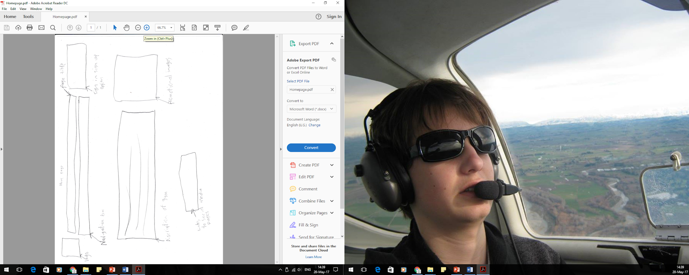

Homepage wireframes

Our client didn’t like having a sign up and login link at the top and thought it would be better to have that in the navigation bar. They also didn’t like the promotional images idea and wanted a price information section instead and told me to go and start again. Next wireframe is on the next page

They did like this one a little bit better but wanted the links and price table side by side so I changed it for the third wireframe. They also said that the price table existed elsewhere and a map of there location would be better. 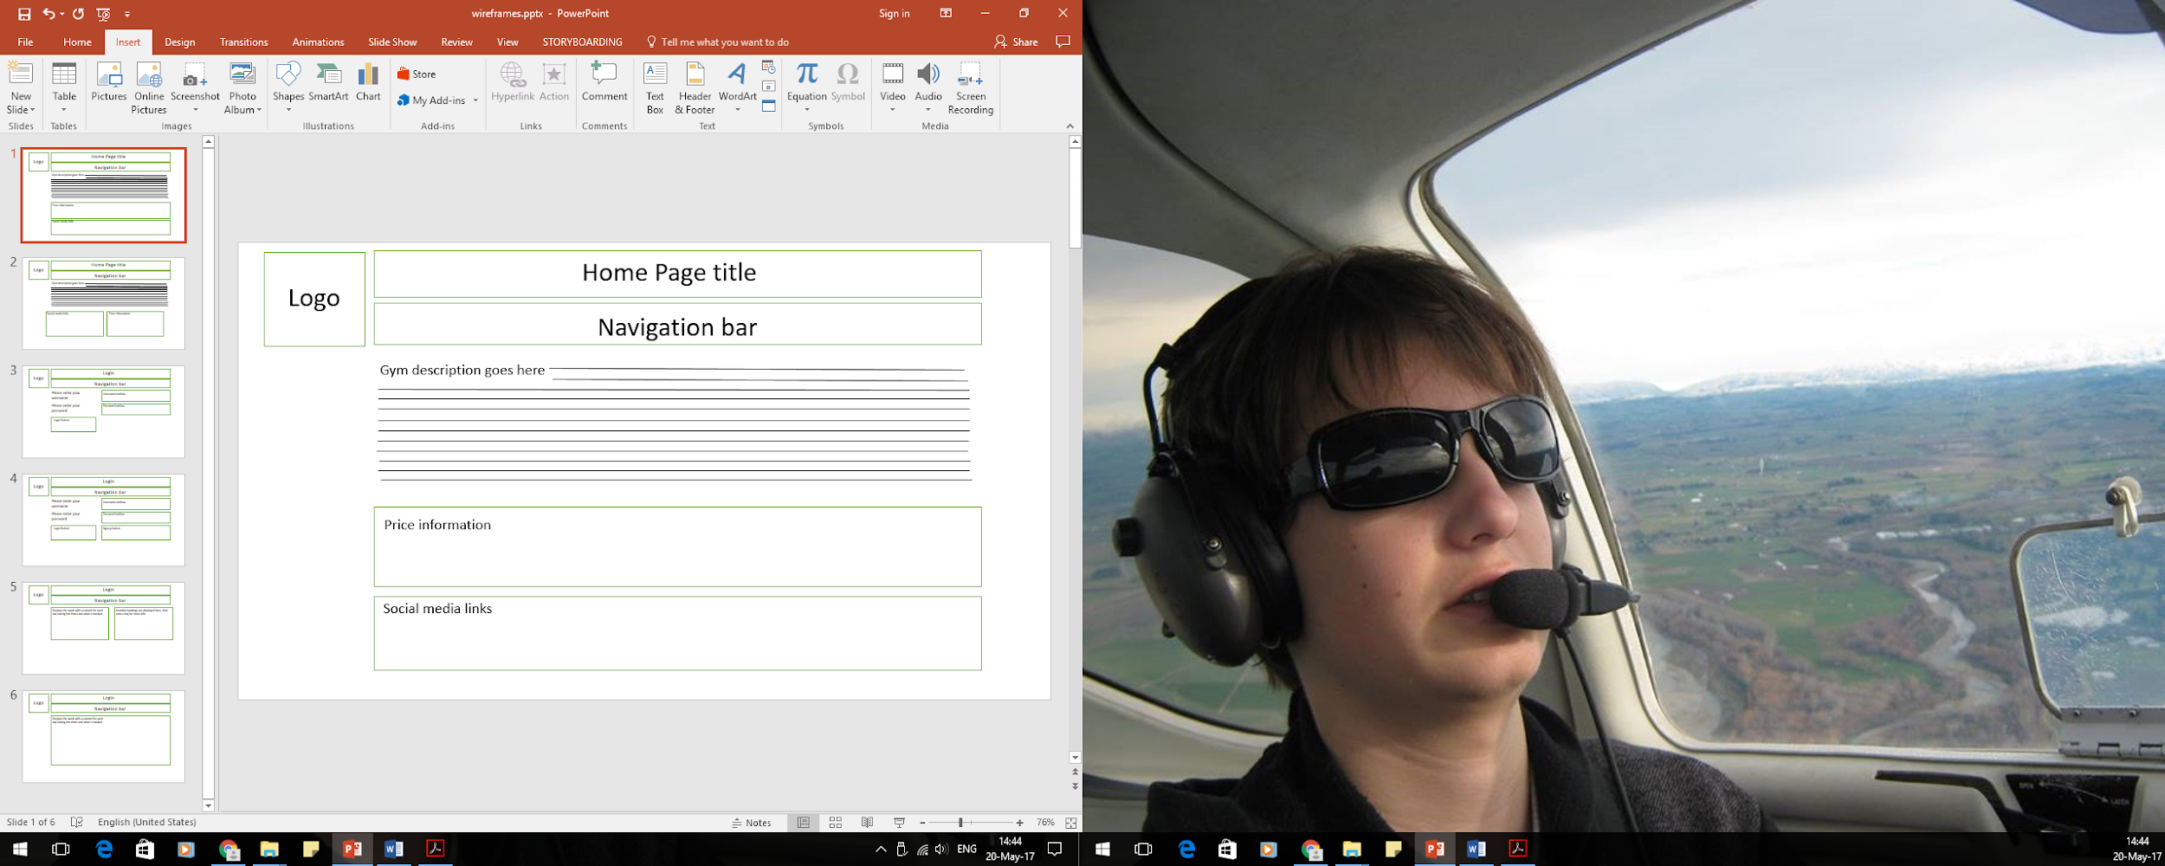

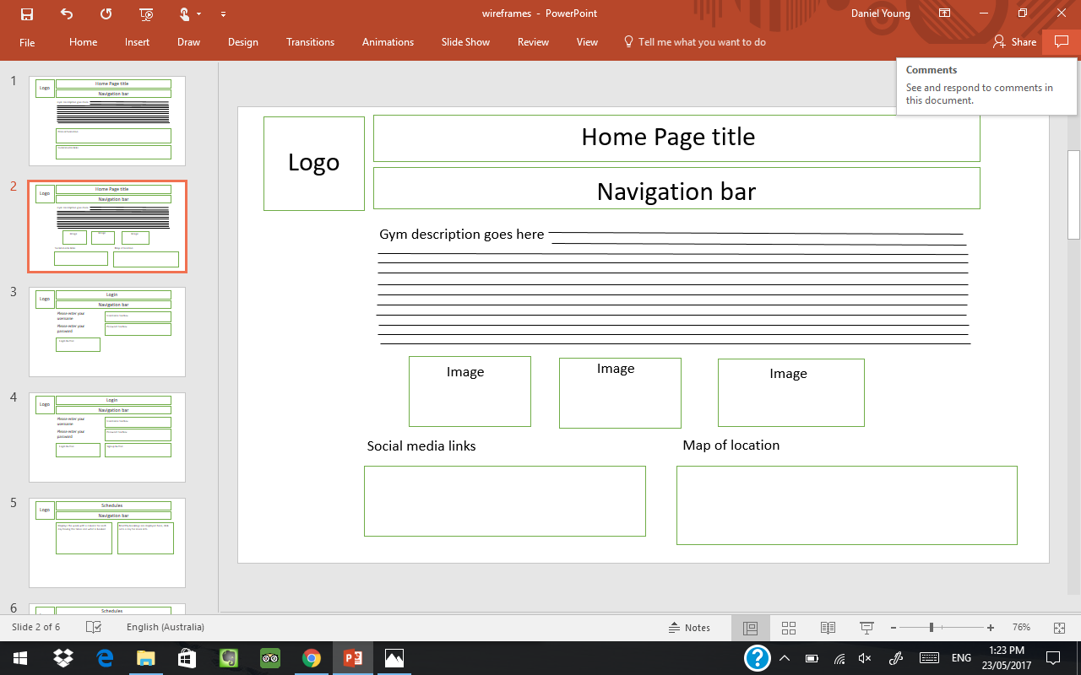

They said that this wireframe was good and liked it.

Login page:

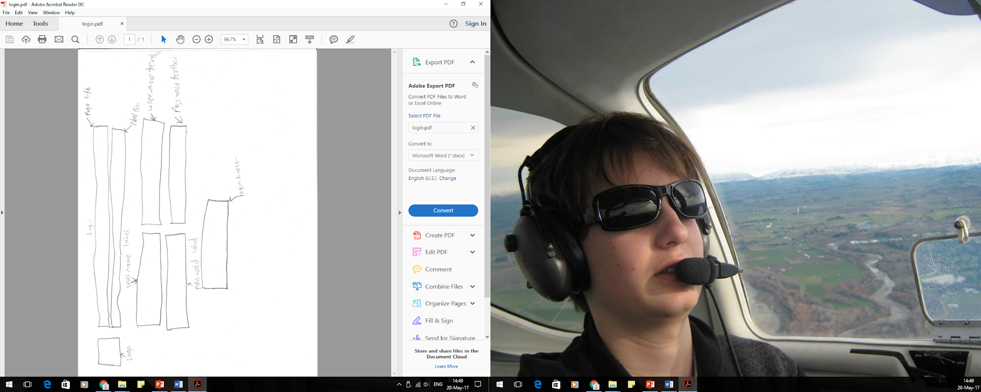

The client thought this was ok but wanted the login button in line with the labels, and wanted the labels to be lined up. Next wireframe is on the next page

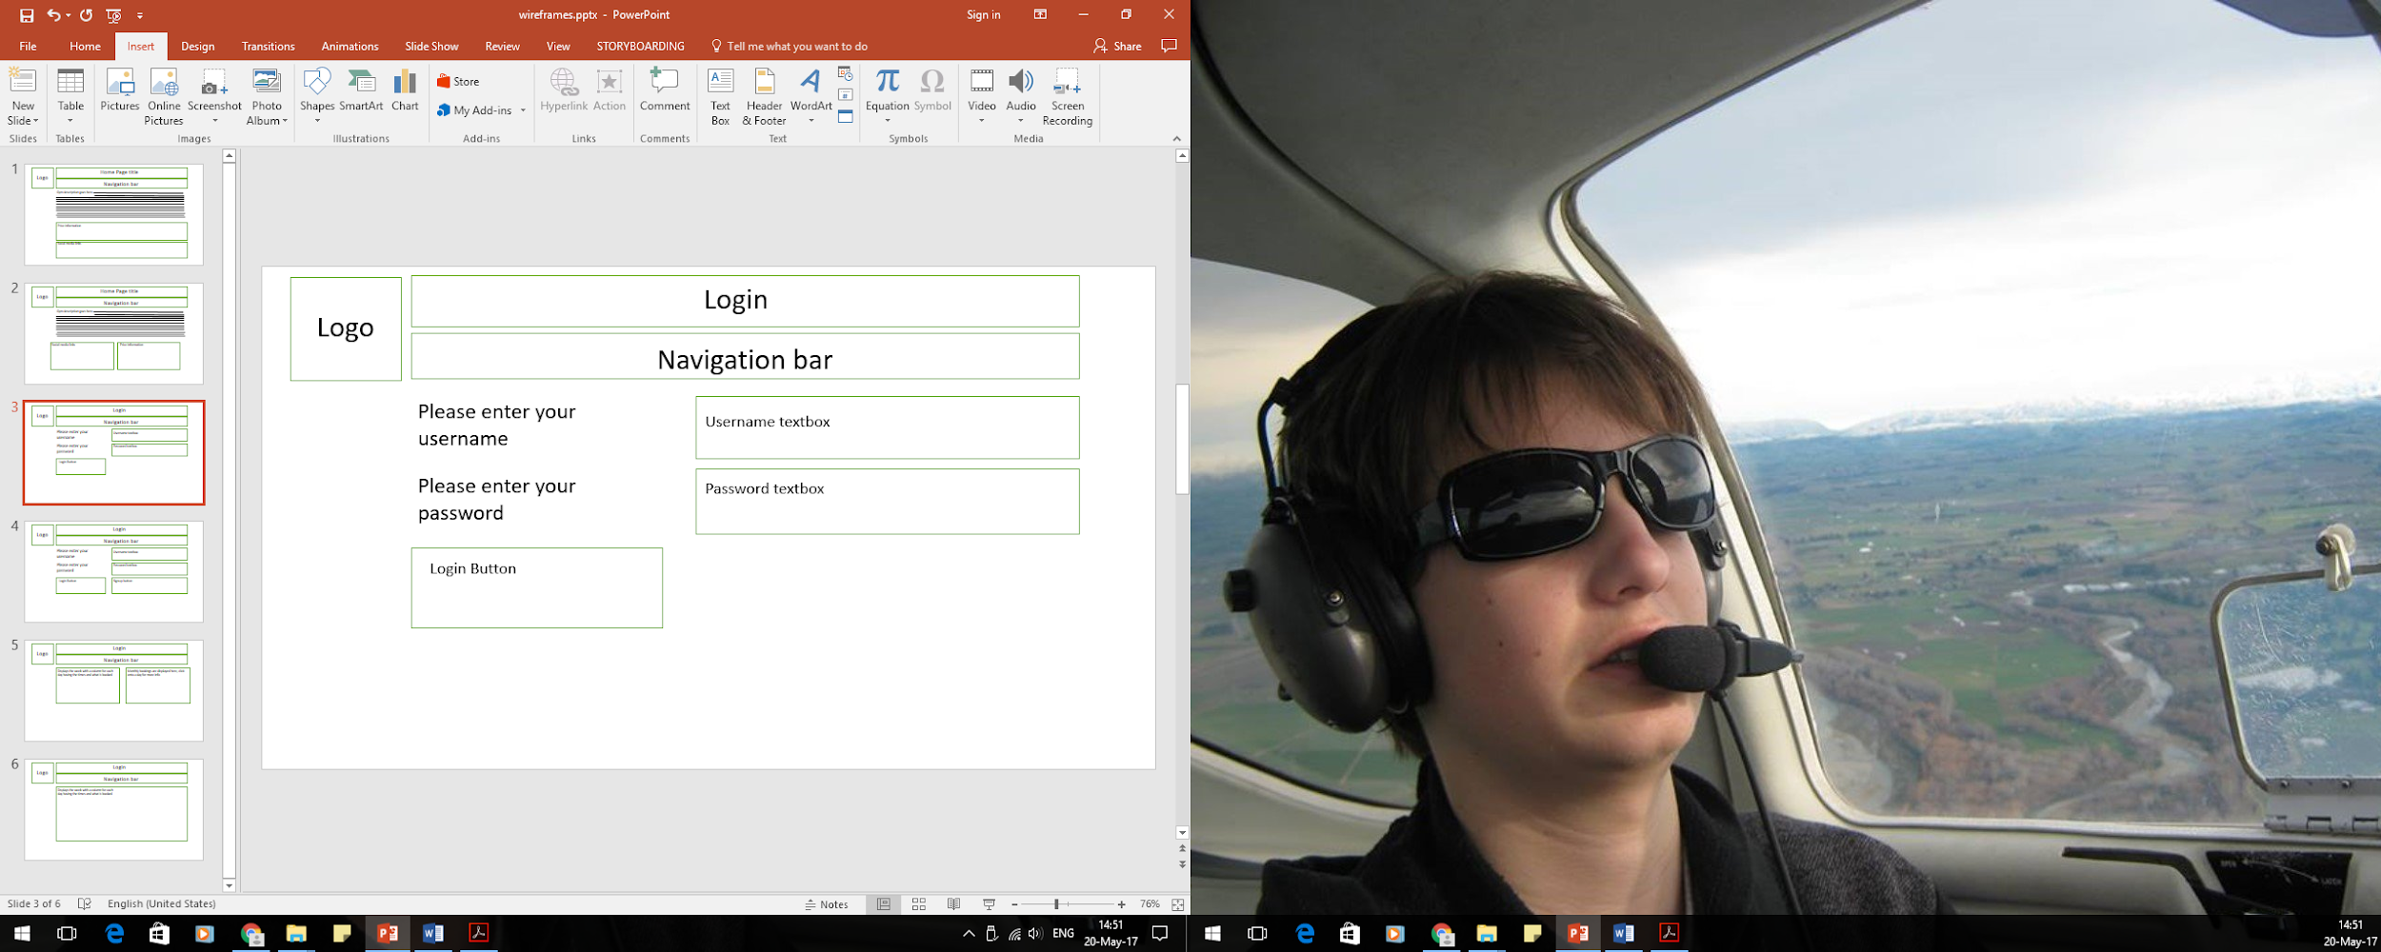

The client likes this layout but was OCD and wanted a signup button next to it to balance the page.

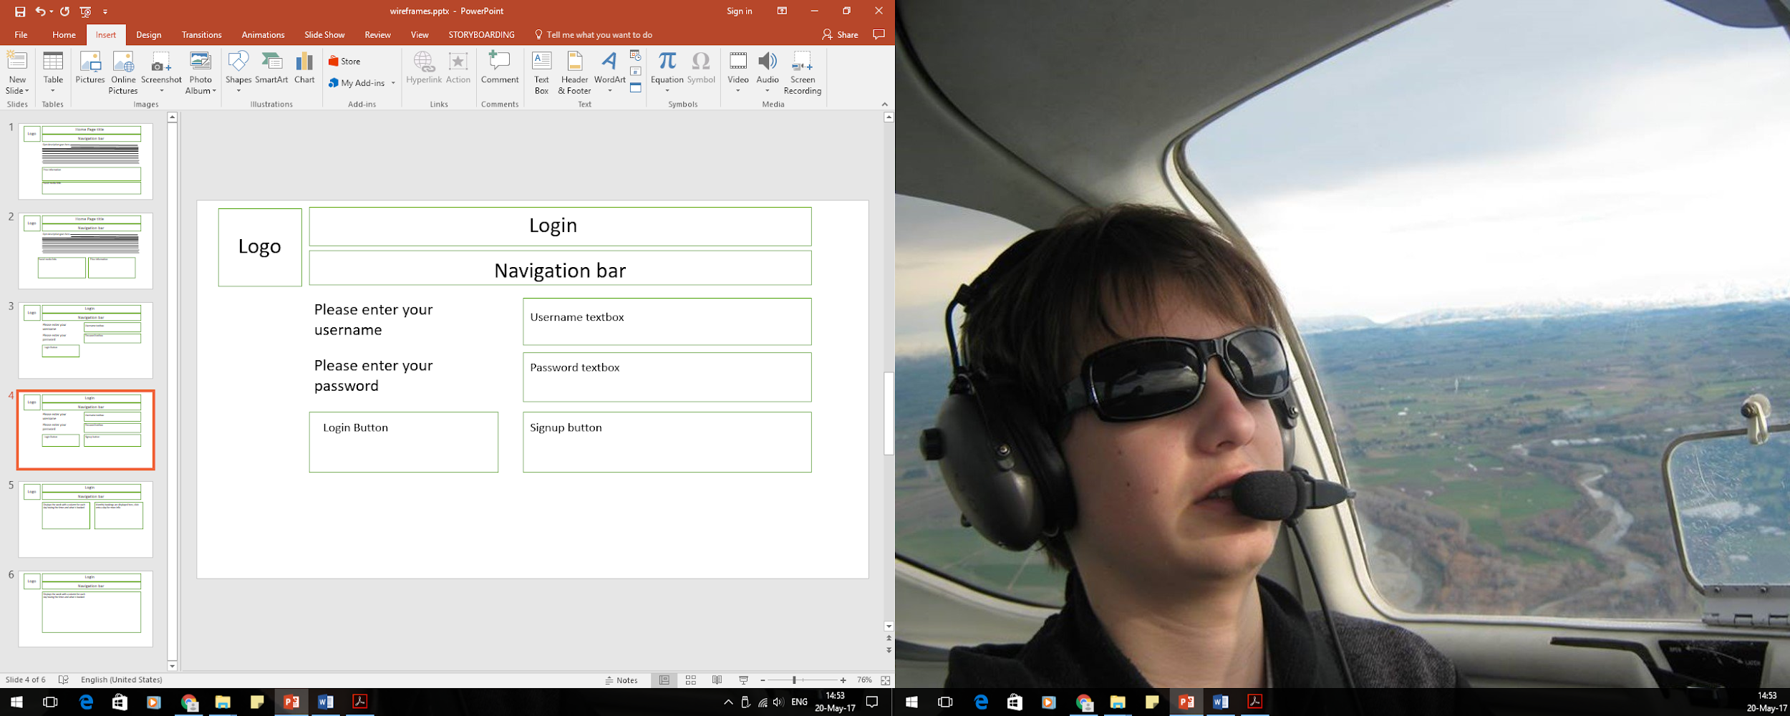

They liked this wireframe and this idea and told me it was good.

Schedule:

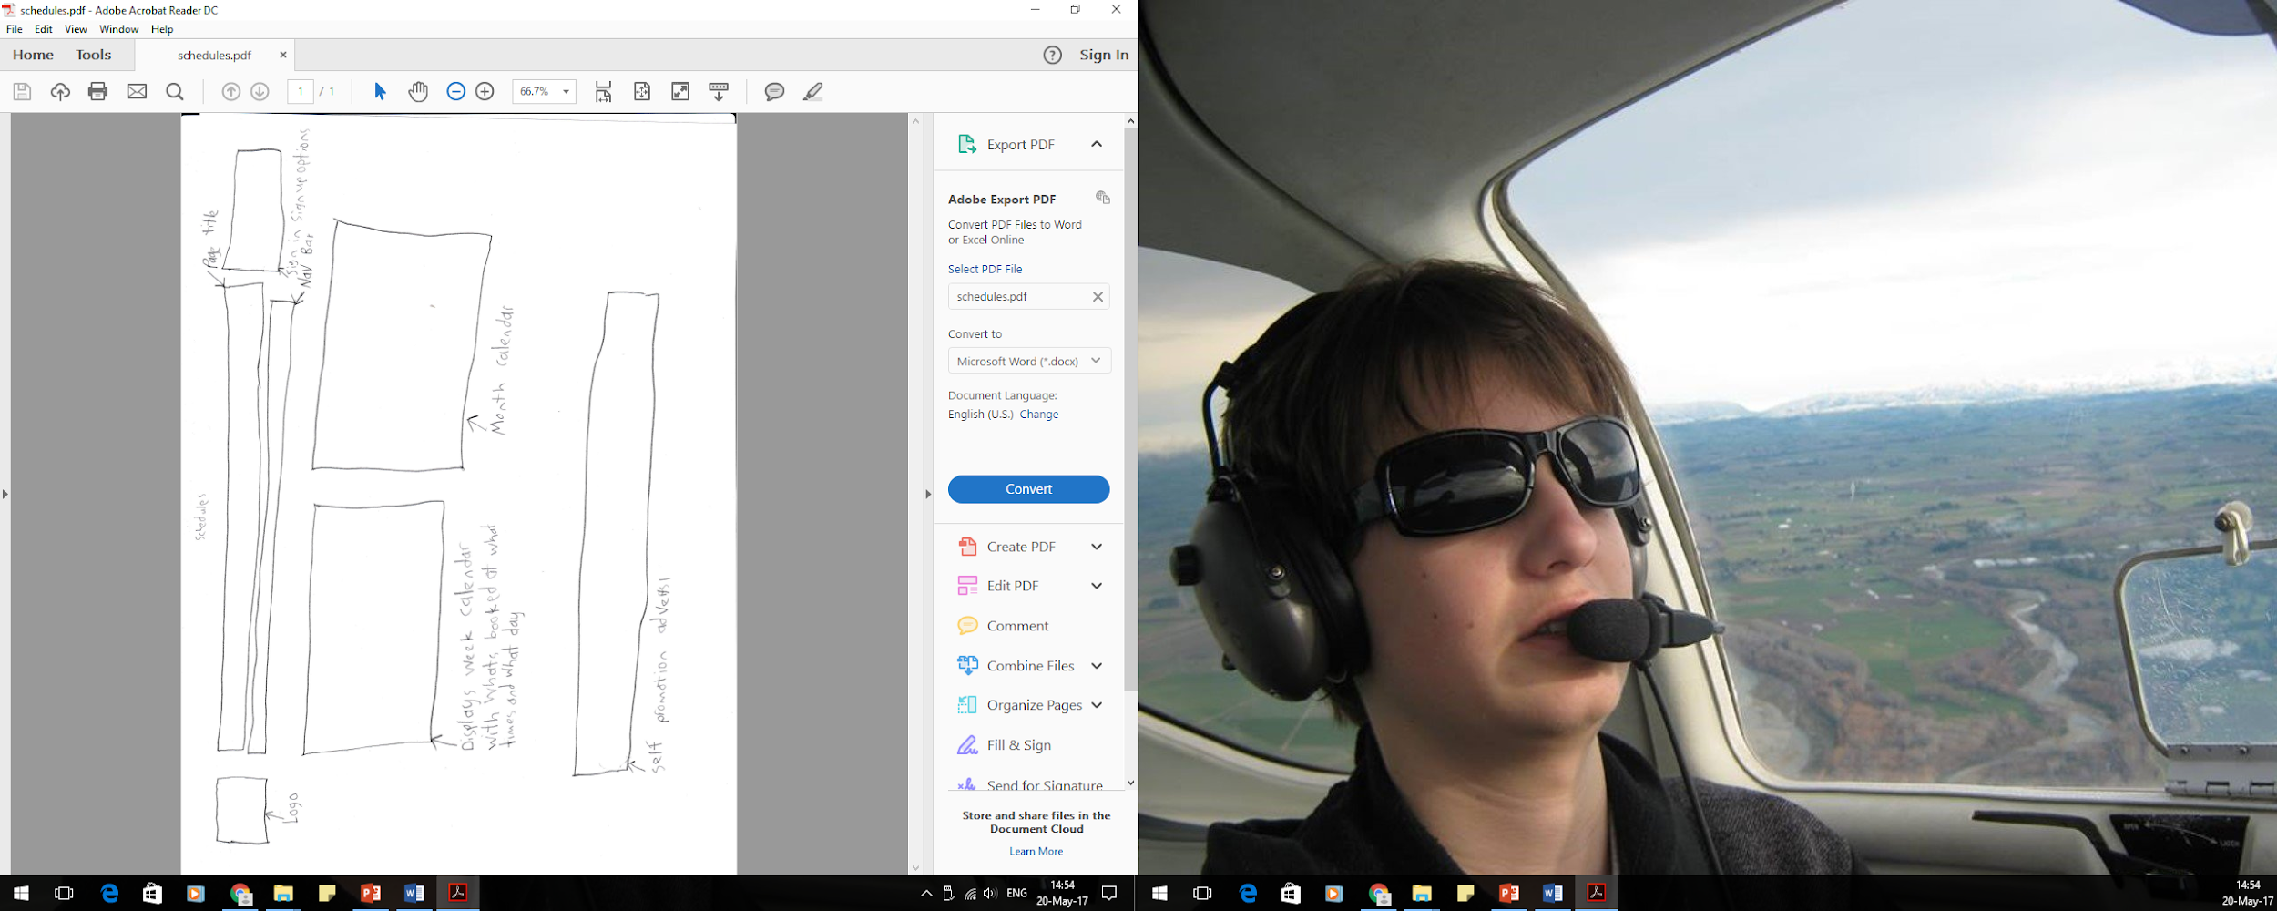

They thought it was ok but didn’t like the promotion adverts so I got rid of it.

